**TAC, Job server, TDS, TDP, IAM, (Nexus) Installation Implementation**

**(8.0.1)**

**Installation Guide & Documentation**

Contents

Section 1: Introduction ……………………………………..3

Section 2: Prerequisites……………………………………..4

Section 3: Installation………………………………………..4

Section 4: Configuration…………………………………….9

Approval

| Signatures by each signatory indicate their acceptance that this document is complete and accurate to the best of his/her knowledge per responsibilities outlined in this document and as guided by approved methodologies and established procedures. | | |
| --- | --- | --- |
| Talend Lead:  Artha Emp | **Subhransu** | **Date:** |
| Project Manager:  Artha Emp | **Pavan Valluri** | **Date:** |
| Talend developer:  Artha Emp | **Omkar Patil** | **Date:** |

# **Section 1: Introduction**

**Talend Data preparation**

Talend Data Preparation is a self-service application that enables information workers to cut hours out of their workday by simplifying and expediting the laborious and time-consuming process of preparing data for analysis or other data-driven tasks. Talend Data Preparation runs on top of the Talend Integration Platform and delivers enterprise-class capabilities together with connectivity to virtually any data source. It fosters collaboration between business people who know the data best and central organizations, like IT or Risk Management, that define the rules and policies for data accessibility and governance.

It includes:

* Integration and cataloging.
* Data Discovery and Profiling.
* Cleansing, standardizing and shaping.
* Enriching and connecting datasets.
* Operationalizing Data Preparation.

**Talend Data Stewardship**

Data stewardship is the practice of ensuring an organization’s data is accessible, trustworthy, usable, and secure. It oversees every stage of the data lifecycle: creating, preparing, using, storing, archiving, and deleting duplicates, in accordance with an organization’s established data governance principles for promoting data quality and health.

**Data stewardship encompasses:**

* Knowing and documenting what types of data an organization possesses (and the quality of the data)
* Understanding where data assets are located and monitoring the use of data.
* Ensuring high-quality data is accessible, usable, safe, and trusted — quickly identifying data quality issues.
* Enforcing data policies, business rules, and initiatives around how a company’s data can be used.
* Helping the organization make most of its business data for competitive advantage.
* Ensuring stakeholders, data owners, and business users create a data-driven culture.

**Installation Environment**

DEV Environment

# **Section 2: Prerequisites**

**Download & Configure Java**

cd /usr/lib

mkdir jvm

Give full permission to jvm folder

wget https://www.oracle.com/in/java/technologies/javase/jdk11-archive-downloads.html#license-lightbox

(or)

#Extract the java file

tar -xvf jdk-11.0.17-linux-x64.tar.gz

#set the java path

Cd /etc/profile.d/jdk.sh

export JAVA_HOME=/usr/lib/jvm/jdk-11.0.18

export PATH=$JAVA_HOME/bin:$JRE_HOME/bin:$PATH

#reboot or restart the server to check java version

java –version

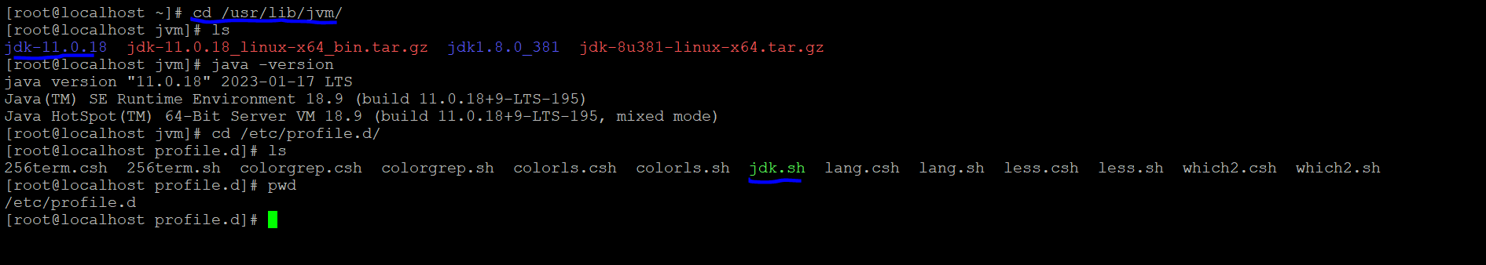

# **Section 3: Installations**

#make a directory of talend folder and keep all the Talend Installations files in it.

Files: - dist, license, Talend-Installer-20211109_1610-V8.0.1-linux-x64-installer.run

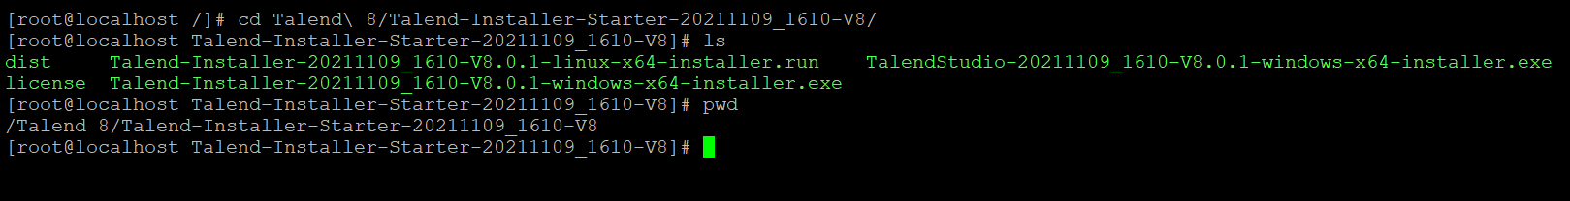

# Run the Linux Installation file.

./Talend-Installer-20211109_1610-V8.0.1-linux-x64-installer.run

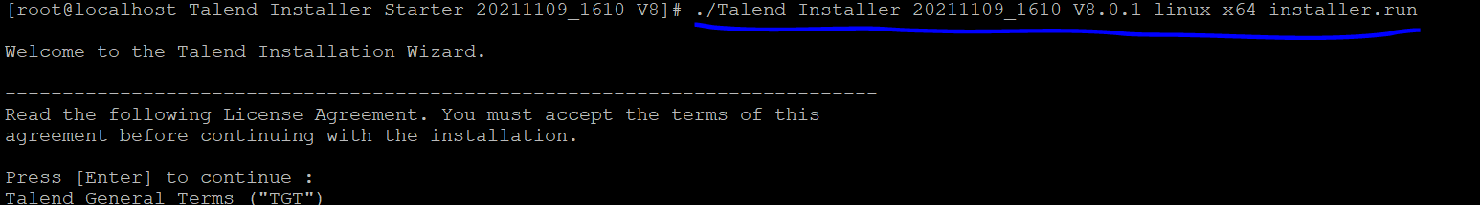

#Do you accept this license? [y/n]: y

Talend installer (v.8.0.1)

# Specify the directory where Talend modules will be installed.

Installation Directory [/opt/Talend-8.0.1]: [/opt/Talend-8.0.1

#Choose the custom Selection mode.

Select an installation mode:

[1] Server - Install all server modules using default settings.

Requires connection details for an existing MySQL 8 server.

[2] Client only - Install Talend Studio only.

[3] Custom - Select the modules to install and set advanced parameters.

Use this option to install both the client and server modules.

Choose an option [1] : 3

# Give the path of license file.

License File: []: /Talend 8/Talend-Installer-Starter-20211109_1610-V8/license

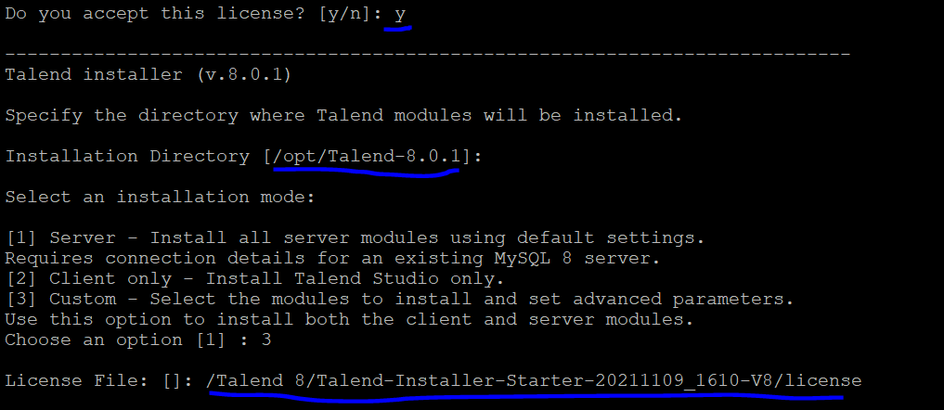

#Select the components to install.

Select the components you want to install; clear the components you do not want

to install. Click Next when you are ready to continue.

Talend Administration Center [Y/n]: y

Talend Log Server [Y/n]: n

Talend IAM Service [Y/n]: y

Talend Data Stewardship [Y/n]: y

Talend Runtime [Y/n]: n

Talend Job Server (Execution Server) [y/N]: y

Talend Data Quality Data Mart [Y/n]: n

Talend Data Preparation [Y/n]: y

Talend SAP RFC Server [Y/n]: n

Talend Studio [Y/n]: n

Talend ESB [Y/n]: n

Talend Server Services [Y/n]: y

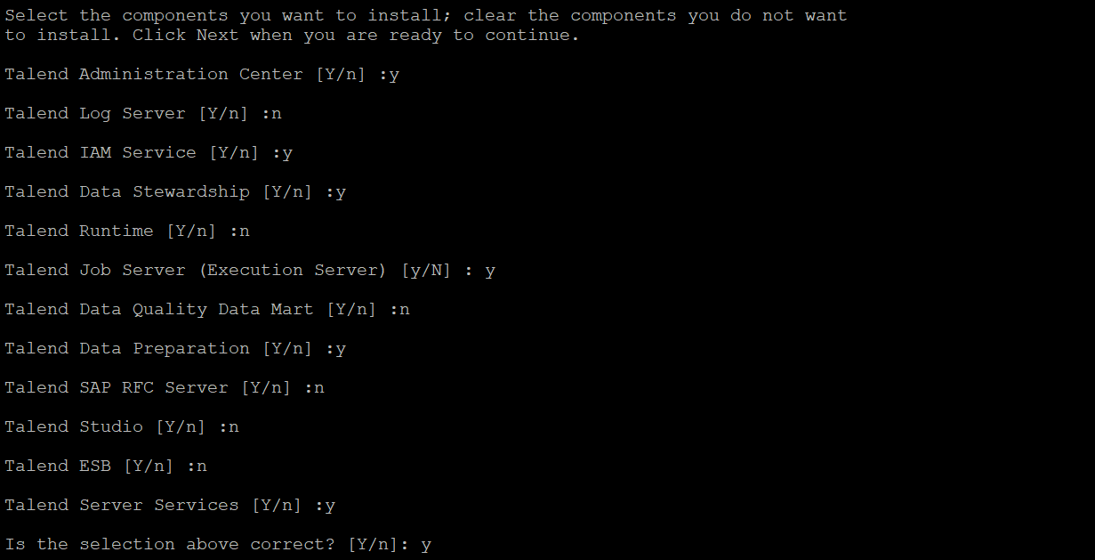Is the selection above correct? [Y/n]: y

# Talend Administration Center Configuration

Talend Administration Center installs on an Apache Tomcat server. Choose one of the options below:

[1] Install an embedded Tomcat 9 server (recommended)

[2] Use an existing Tomcat server

Choose an option [1]: 1

[1]: Create TAC administrator user:

[2] Enable SSO (default TAC administrator user will not be created in TAC)

Choose an option [1]: 1

# Create TAC administrator user:

Admin user name [security@company.com]: security@company.com

Admin password [********]: admin

# Use Log Server for Talend Administration Center [y/N]: y

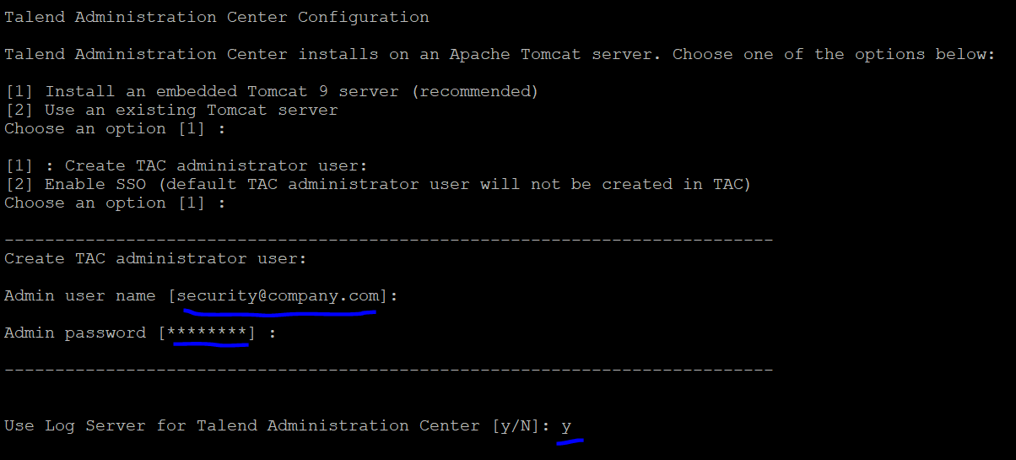

# Talend Administration Center Configuration

tacDB

Talend Administration Center connects to a database to store its configuration and metadata. Select the database type:

[1] MySQL

[2] H2 Embedded (not recommended)

[3] Oracle

[4] Microsoft SQL Server

[5] PostgreSQL

Choose an option [1] : 2

Talend Administration Center port (Tomcat port)

[8080]:

Name of Talend web application directory within Tomcat:

[org.talend.administrator]: org.talend.administrator

Configure connections to repositories [y/N]: y

# Talend Administration Center - Repository connection configuration

Configure connection to Talend update site [y/N]: y

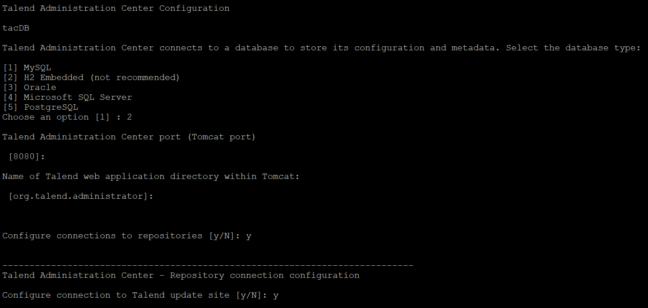

# Give the username and password which came License

URL [https://talend-update.talend.com/nexus]: https://talend-update.talend.com/nexus

User name []: jorawarsingh

Password :

# Talend Administration Center - Repository connection configuration (continued)

Local repository to store downloads from Talend update site [y/N]: y

# Repository type

[1] Nexus 3

[2] Nexus 2 (deprecated)

[3] Artifactory

Choose an option [1] :

URL []: http://192.168.1.179:8081/

Deployment user name []: admin

Deployment password: admin

Reader user name []: admin

Reader password: admin

Repository ID []: talend-updates

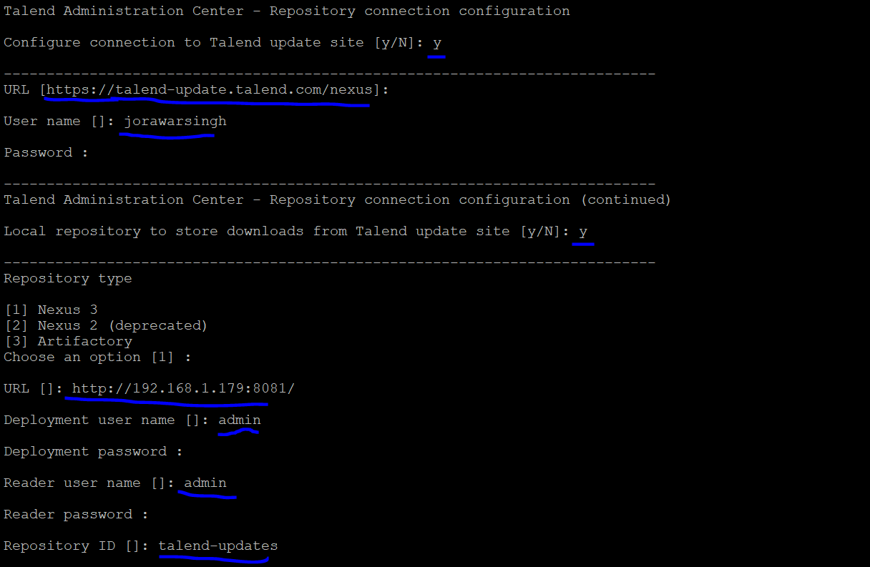

# Talend Administration Center - Repository connection configuration (continued)

Repository to store job artifacts [y/N]: y

# Repository type

[1] Nexus 3

[2] Nexus 2 (deprecated)

[3] Artifactory

Choose an option [1]:

URL []: http://192.168.1.179:8081/

User name []: admin

Password: admin

Default release repo [releases]:

Default snapshot repo [snapshots]:

# Talend Administration Center - Repository connection configuration (continued)

Local repository to store custom libs [y/N]: y

# Repository type

[1] Nexus 3

[2] Nexus 2 (deprecated)

[3] Artifactory

Choose an option [1] :

URL []: http://192.168.1.179:8081/

User name []: admin

Password : admin

Default repository for releases [talend-custom-libs-release]:

Default repository for snapshots [talend-custom-libs-snapshot]:

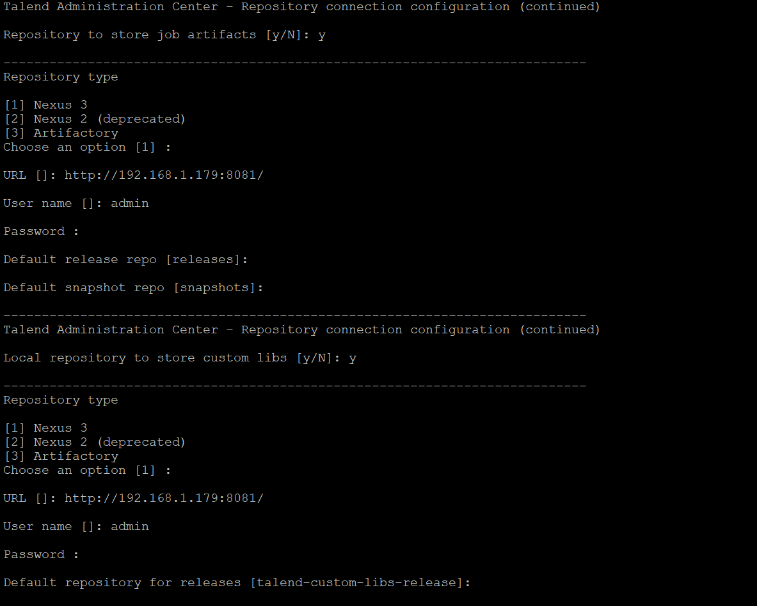

# Talend Identity and Access Management

Select Tomcat for IAM application

[1]: Use a dedicated tomcat for IAM

[2] Use Talend Administration Center Tomcat for IAM

[3]: Use an external tomcat for IAM

Choose an option [1]:

# Use a dedicated tomcat for IAM

Dedicated Tomcat with port: [9080]:

# Talend Administration Center authentication

Talend Administration Center URL: [http://localhost:8080/org.talend.administrator]: http://192.168.1.179:8080/org.talend.administrator

Talend Administration Center user: [security@company.com]:

Talend Administration Center password: [********] : admin

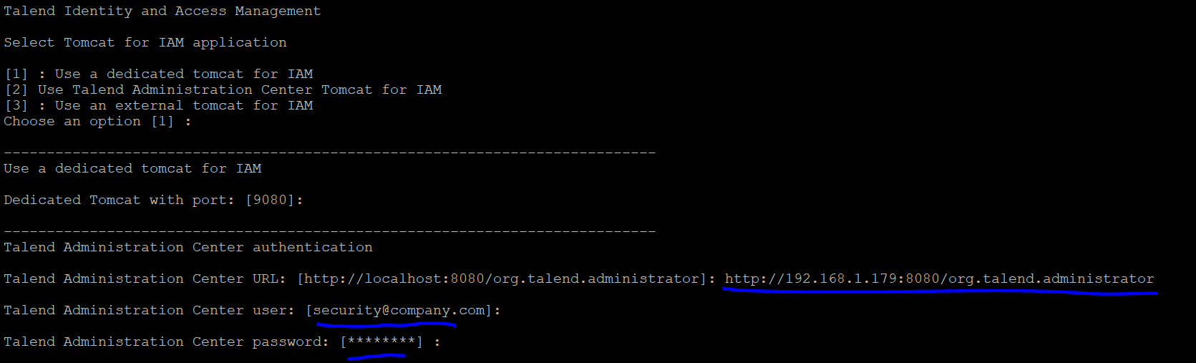

# IAM internal configuration

IAM host name: [localhost]: 192.168.1.179

Language:

[1] English

[2] French

[3] Japanese

[4] Chinese

Choose an option [1] : 1

# Talend Identity and Access Management

# Talend Data Stewardship

Post-logout redirection URL:

[http://localhost:19999/]: <http://192.168.1.179:19999/>

# Talend Data Preparation

Post-logout redirection URL:

[http://localhost:9999/]: <http://192.168.1.179:9999/>

# Talend MDM

Post-logout redirection URL:

[http://localhost:8180/]: <http://192.168.1.179:8180/>

# Talend Dictionary Service Configuration

Tomcat configuration parameters

Tomcat port: [8187]:

#Use Audit enablement for Talend Log Server: [y/N]: y

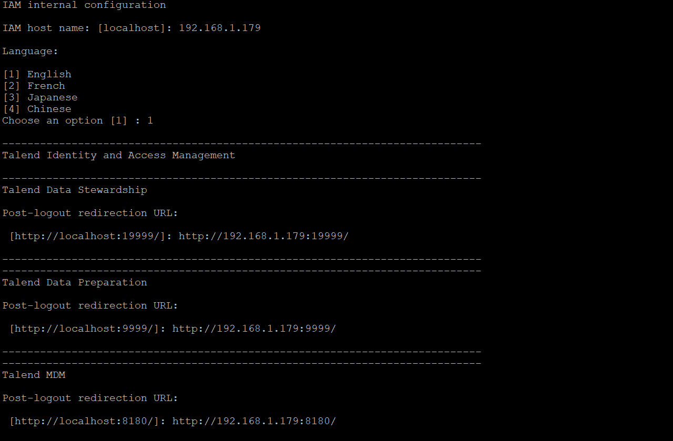

# Talend Dictionary Service Configuration

Select MongoDB instance:

[1]: --- Embedded (will install a new local MongoDB instance) ---

[2]: --- External MongoDB connection ---

Choose an option [1]:

# --- Embedded (will install a new local MongoDB instance) ---

MongoDB Port: [27017]:

# Embedded MongoDB

# Talend Dictionary Service Configuration

Talend Identity Access Management connection parameters

IAM URL: [http://localhost:9080]: http://192.168.1.179:9080

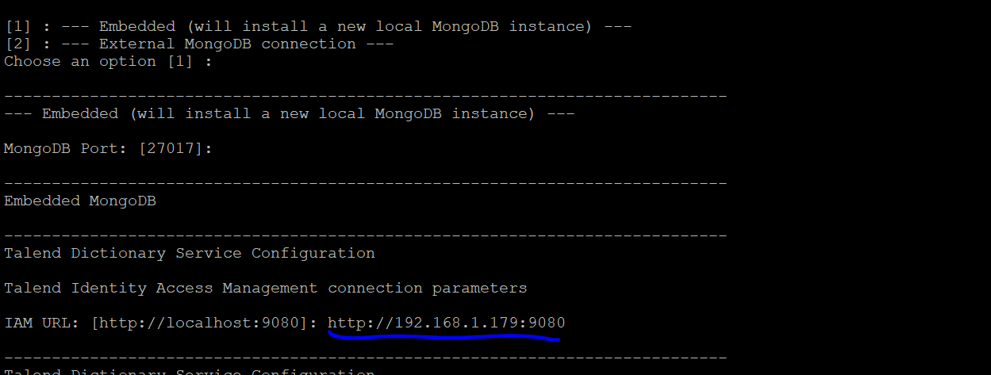

# Talend Dictionary Service Configuration

Choose S3 connection mode:

[1]: --- Use embedded MinIO server ---

[2]: --- Connect to external AWS S3 / MinIO server ---

Choose an option [1]:

# --- Use embedded MinIO server ---

MinIO Port: [9000]:

Bucket name: [default-bucket]:

# Talend Data Stewardship Configuration

Talend Data Stewardship requires an Apache Tomcat server. Select one of the options below

[1] : Embedded Tomcat 9 server (recommended)

[2] : Use an existing Tomcat server

Choose an option [1] :

# Embedded Tomcat 9 server (recommended)

UI port (Tomcat port): [19999]:

# Use Talend Log Server (audit): [y/N]: y

# Talend Data Stewardship Configuration

Select MongoDB instance:

[1]: --- Embedded (will install a new local MongoDB instance) ---

[2]: --- External MongoDB connection ---

Choose an option [1]:

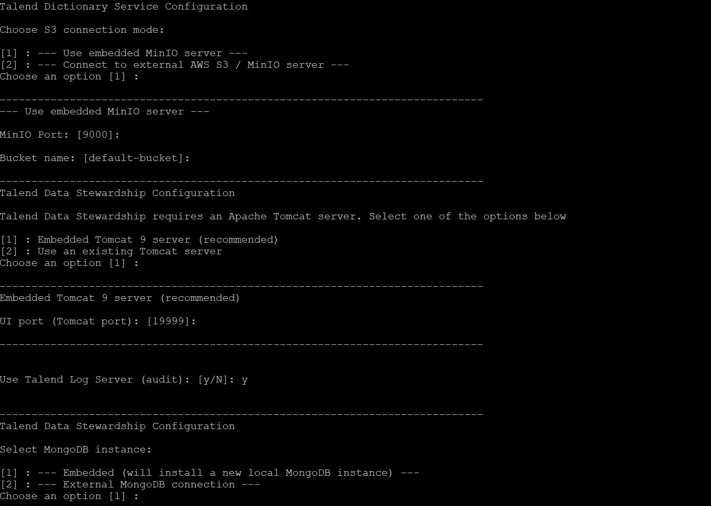

# Embedded Tomcat 9 server (recommended)

UI port (Tomcat port): [19999]:

# Use Talend Log Server (audit): [y/N]: y

# Talend Data Stewardship Configuration

Select MongoDB instance:

[1]: --- Embedded (will install a new local MongoDB instance) ---

[2]: --- External MongoDB connection ---

Choose an option [1]:

# --- Embedded (will install a new local MongoDB instance) ---

MongoDB port: 27017

# Talend Data Stewardship Configuration

Select Kafka and Zookeeper instances:

[1] : --- Embedded - Kafka and Zookeeper will be installed locally ---

[2] : --- External Kafka and Zookeeper ---

Choose an option [1] :

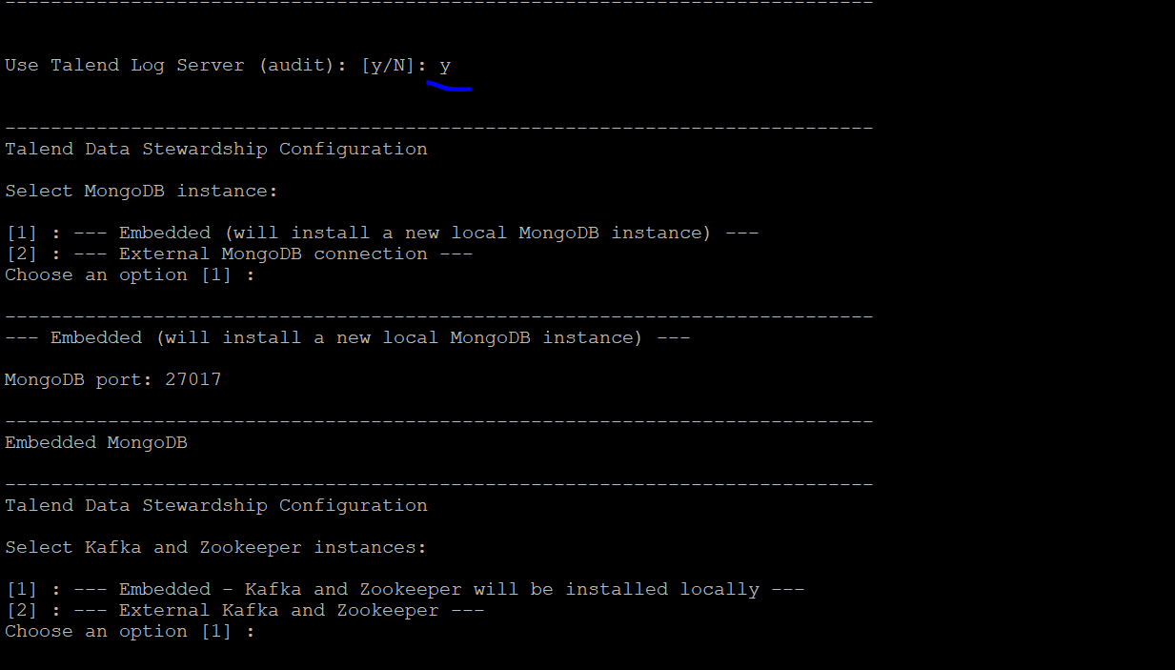

# --- Embedded - Kafka and Zookeeper will be installed locally ---

Kafka port: [9092]:

Zookeeper port: [2181]:

# Talend Data Stewardship Configuration

Talend IAM parameters:

IAM URL: [http://localhost:9080]: <http://192.168.1.179:9080>

# Talend Job Server Configuration

This page configures the Talend Remote Job Server, including setting the ports

used to communicate with the Talend Administration Center.

Command port [8000]:

File transfer port [8001]:

This option enables cleaning of any cached files and logs after a given

duration. Set this value to 0 to disable log purging

Max cache duration (days) [90]:

Monitoring port [8888]:

Process messaging port [8555]:

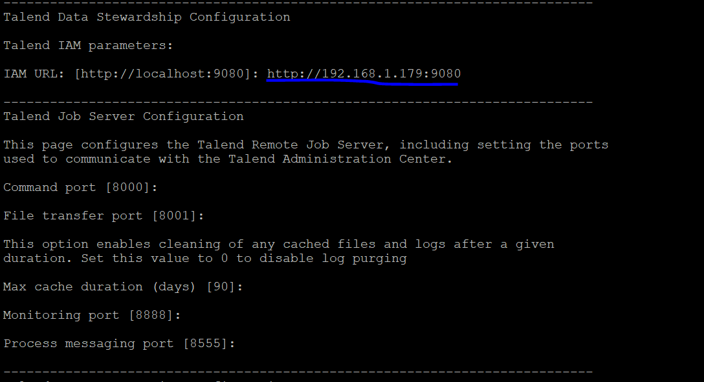

# Talend Data Preparation Configuration

Select MongoDB instance:

[1]: --- Embedded (will install a new local MongoDB instance) ---

[2]: --- External MongoDB connection ---

Choose an option [1]:

# --- Embedded (will install a new local MongoDB instance) ---

MongoDB port: 27017

# Data Preparation Server configuration

Talend Administration Center parameters:

Talend Administration Center URL [http://localhost:8080/org.talend.administrator/]: http://192.168.1.179:8080/org.talend.administrator/

Data Preparation Server parameters:

Server Public Hostname: [localhost]: 192.168.1.179

UI port: [9999]:

Backend port: [8989]:

Talend Identity Access Management connection parameters

IAM URL: [http://localhost:9080]: http://192.168.1.179:9080

Use Talend Log Server (audit) [y/N]: y

# Talend Kafka and Zookeeper configuration

Apache and Zookeeper parameters

Zookeeper data directory: [/opt/Talend-8.0.1/kafka/temp]:

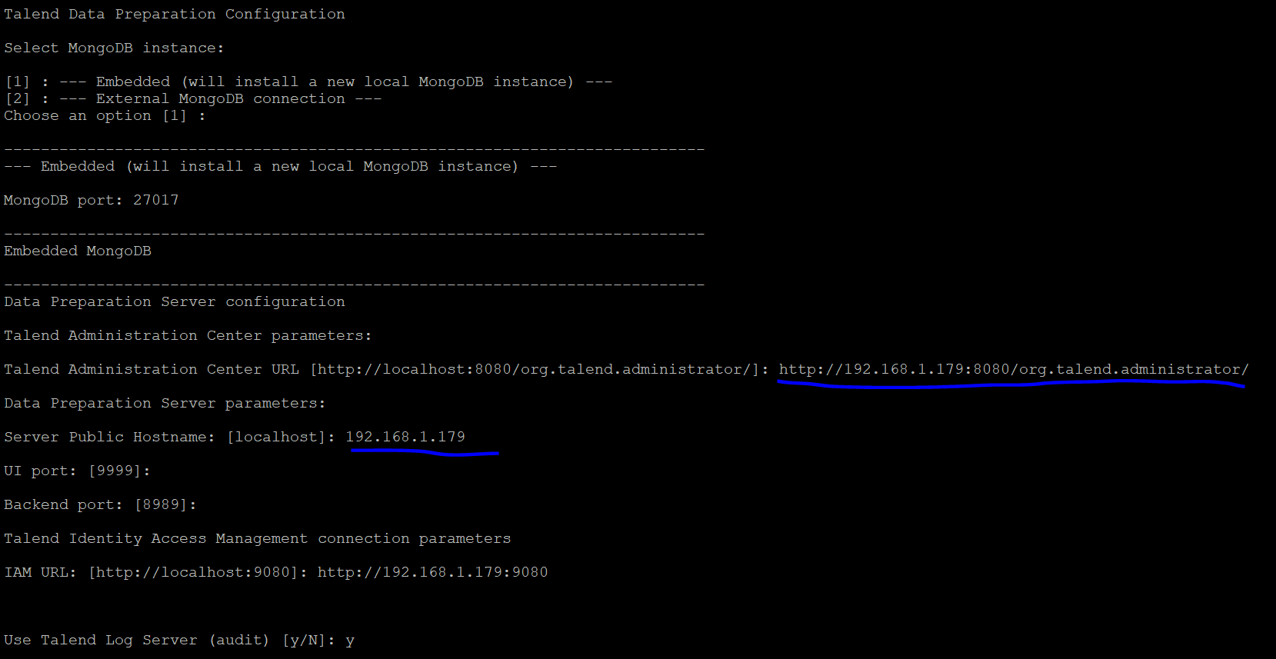

# Audit Client Configuration

Talend Log Server (audit) HTTP host: [localhost]: 192.168.1.179

Talend Log Server (audit) HTTP port: [8057]:

# System Services Installation

# The following user and group will be used for system services:

User: [talenduser]: root

Group: [talendgroup]: root

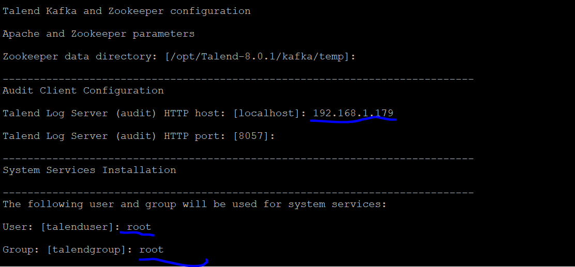

# Install Talend Administration Center as a service [Y/n]:

Install Talend IAM server as a service [Y/n]: y

Install Talend Job Server as a service [Y/n]: y

Install Talend Data Stewardship as a service [Y/n]: y

Install Talend Data Preparation as a service [Y/n]: y

Install Talend Dictionary Service as a service [Y/n]: y

#System Services Installation (support services)

Install Apache Kafka and Apache Zookeeper as services [Y/n]: y

Install MongoDB as a service [Y/n]:

Install Talend Filebeat as a service [Y/n]: y

Install Talend MinIO as a service [Y/n]: y

# Setup is now ready to begin installing Talend on your computer.

Do you want to continue? [Y/n]: y

# Please wait while Setup installs Talend modules on your computer.

Installing

0% ______________ 50% ______________ 100%

###############################about to fork child process, waiting until server is ready for connections.

forked process: 4331

child process started successfully, parent exiting

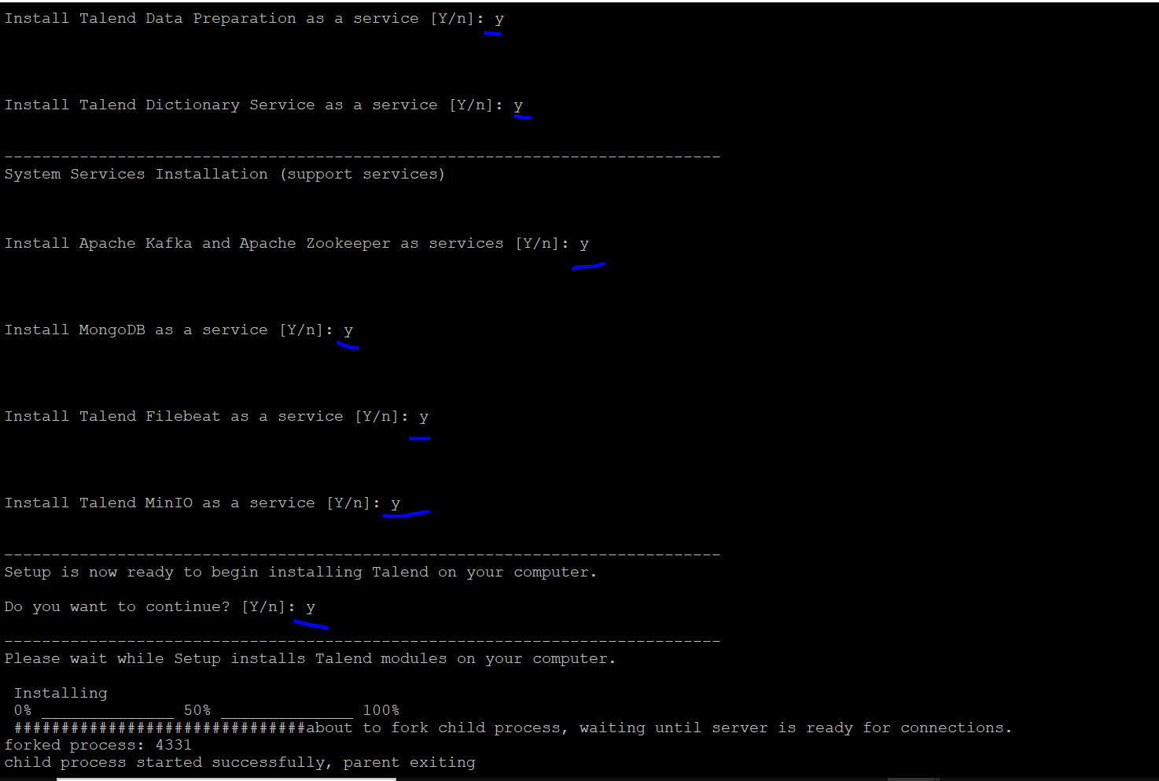

============================================

# TAC memory setting

cd /opt/Talend-8.0.1/tac/apache-tomcat/bin

vi setenv.sh

xms size 2G and xmx sixe is 12G

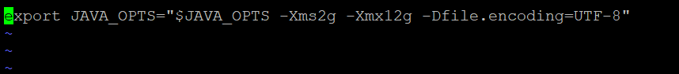

# Apply IPV4 settings from Jared

cd /etc/sysctl.d

vi 90-keepalive.conf

net.ipv4.tcp_keepalive_intvl = 60

net.ipv4.tcp_keepalive_probes = 30

net.ipv4.tcp_keepalive_time = 180

*SAVE*

*run*

sysctl -f 90-keepalive.conf

==================================================

# check all the services

cd /etc/system/system

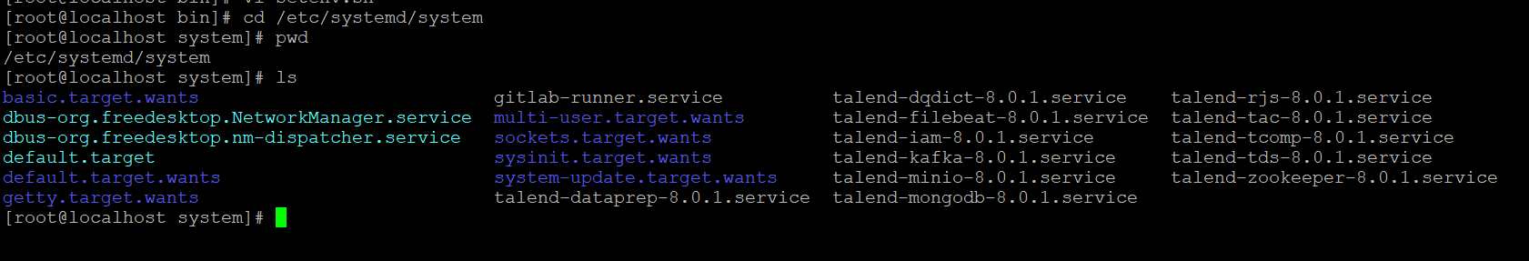

============================================

#check all the services are running.

sytemctl status talend*

============================================#create the logs directories

cd /srv/

mkdir fileshare

cd fileshare

mkdir Talend

Audit - /srv/fileshare/Talend/Audit/reports

Job Conductor - /srv/fileshare/Talend/Administrator/generatedJobs

Job Conductor - /srv/fileshare/Talend/Administrator/executionLogs

Logs - /srv/fileshare/Talend/Administrator/executionLogs/technicalLog/technical.log

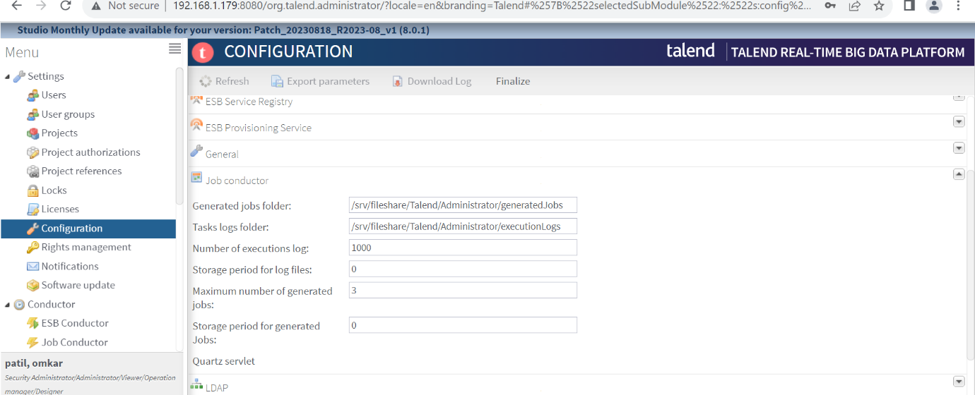Logs - /srv/fileshare/Talend/Administrator/executionLogs/businessLog/business.log

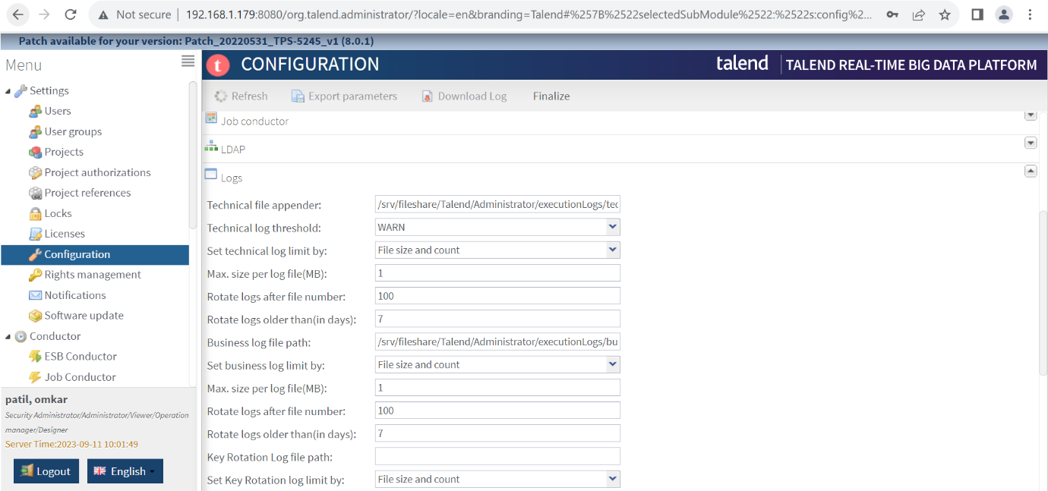

# IAM url login

http:{ip_address}:9080/syncope-console

note: default username and password

username: - admin

password: - password

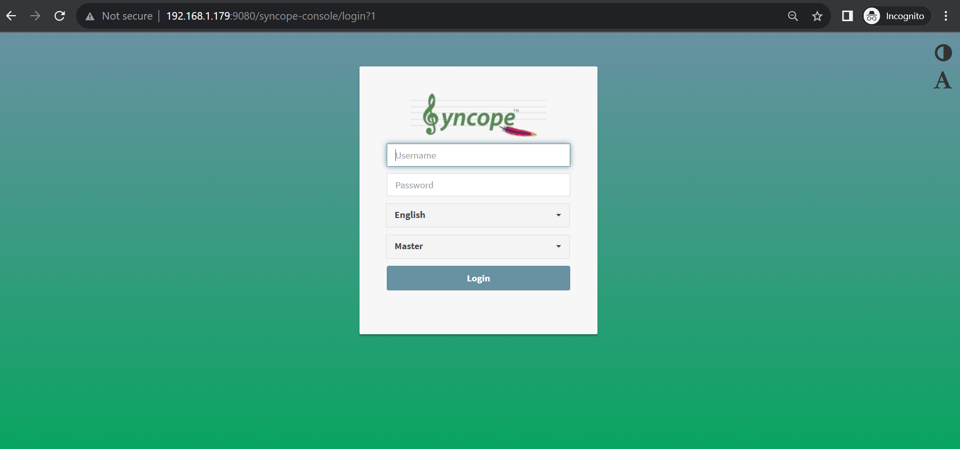

# TDS url

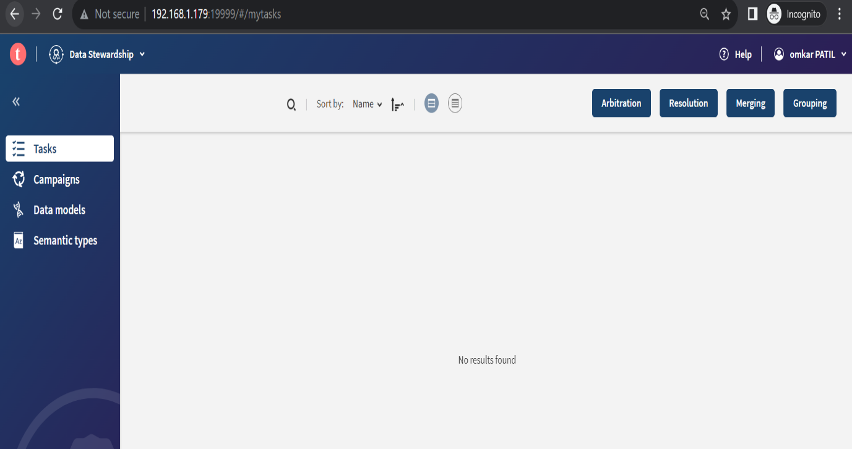http:{ip_address}:19999/

# TDP url

http:{ip_address}:9999/

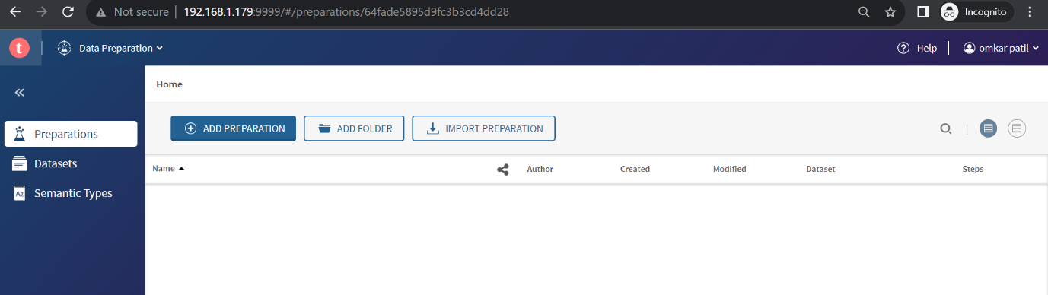

#Nexus url

http:{ip_address}:8081/

